|  |
| --- |
| PS2Win |
| Define Processes List |
| KeepYourTIme |

|  |
| --- |
| João Girão  23-02-2013 |

Content

1. Introduction 1

2. Processes List 1

3. Estimates 2

4. Process Map 3

**Images**

Figure 1 Process Map 3

**Tables**

Table 1: List of Contributors ii

Table 2: Version history ii

Table 3: Process List with priorities 1

Table 4: Process Definition Estimates 2

|  |  |  |  |
| --- | --- | --- | --- |
| **Authors and Contributors** | | | |
| **Date** | **Name** | **Contacts** | **Contribution** |
| 23-02-2013 | João Girão | a21170831@alunos.isec.pt | Author |
| 02-03-2013 | Carla Machado | a21170460@alunos.isec.pt | contributor |
| 22-04-2013 | Mário Oliveira | a21170292@alunos.isec.pt | Contributor |
|  |  |  |  |

Table 1: List of Contributors

|  |  |  |  |  |  |
| --- | --- | --- | --- | --- | --- |
| **Revision History** | | | | | |
| **Date** | **Description** | **Author** | **Version** | **Approvers** | **State** |
| 23-02-2013 | Creation of first draft | João Girão | 0.1 |  | Draft |
| 02-03-2013 | Updating list and orders. Adding estimates. | Carla Machado | 0.2 |  | Draft |
| 09-03-2013 | Updating List Processes | João Girão | 0.3 |  | Draft |
| 17-03-2013 | Changes to the processes | Carla Machado | 0.4 |  | Draft |
| 21-04-2013 | Change document: estimation table | João Girão | 0.5 |  | Ready for Revision |
| 22-04-2013 | Document reviewed | Mário Oliveira | 0.5 |  | Ready for Revision |
| 22-04-2013 | Change Document | João Girão | 0.6 |  | Ready for Approval |
|  |  |  |  |  |  |

Table 2: Version history

# Introduction

This document describes a list of processes to be implemented and followed throughout the software project. The processes are based on the standards of ISO 12207-2008.

# Processes List

|  |  |  |  |
| --- | --- | --- | --- |
| **Priority** | **Process** | **Summary Description** | **When we will need them** |
| **1** | Document Management Process | Process to use in the creation and updating of documents | Since the beginning |
| **2** | Project Planning Process | Process to build a development plan (tasks, estimation, resource allocation) | Since the beginning |
| **2** | Requirements Analysis Process | Process to use in the specification of system requirements | During Requirements Analysis phase.  After Kickoff Meeting |
| **3** | Project Assessment and Control Process (include Risk Management Process) | Process to define progress tracking and change control.  Risk analysis | After Software Requirements Specification |
| **3** | Review Process | Process for reviewing code and documents produced. | After Project planning and Requirements analysis. First major documents |
| **5** | Verification & Validation Process | Process to help software verification and validation (tests). | During Verification & Validation phase. |

Table 3: Process List with priorities

# Estimates

In this chapter the estimates for definition of each process will be presented.

In order to make these estimates each team member studied and analysed two types of processes.

Each person gave three estimates to each project an optimistic one an expected and a pessimist one.

Considering these three estimates an average was calculated giving different weights to each one. The assigned weights were 60%, 25% and 15% to the expected, the pessimist and the optimistic one.

Finally an average of the estimates of the various members that analyzed the same process was made.

|  |  |  |
| --- | --- | --- |
| **Priority** | **Processes** | **Team Members** |
| **1** | Document Management Process | Carla Machado  &  Mário Oliveira |
| **2** | Project Planning Process | Filipe Brandão  &  João Martins |
| **2** | Requirements Analysis Process | Carla Machado  &  João Girão |
| **3** | Project Assessment and Control Process (Risk Management Process) | Rui Ganhoto  &  David Silva  &  Carla Machado |
| **3** | Review Process | Filipe Brandão  &  Mário Oliveira |
| **4** | Verification & Validation Process | João Martins  &  João Girão |

Table 4: Process Definition Estimates

# Process Map

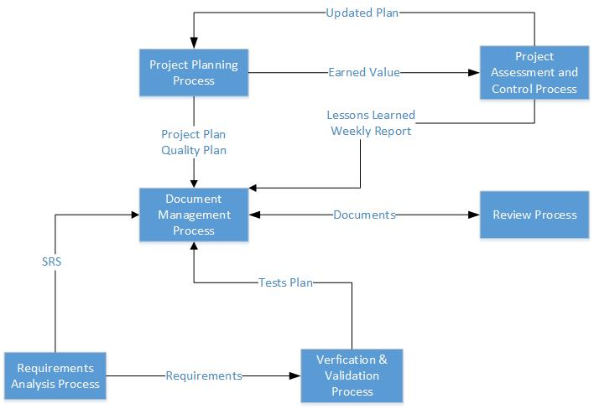

Figure 1 Process Map